Food Delivery Sales &

Customer Insights

STUDENT NAME: SREEJA G

YEAR: II Year

COLLEGE CODE:104

COLLEGE NAME: CSI Jayaraj Annapackiam College,Nallur

DEPARTMENT: B.Sc.Computer Science

SEMESTER: 4th Semester

ROLL NO: 24081041802112135

NMID: 5B2482E88A90E84A2F44CDFD49630413

TITLE: Food Delivery Sales & Customer Insights

GITHUB LINK :

DATE: 21.06.2026

Food Delivery Sales &Customer Insights

1. ABSTRACT

Project Overview
This project analyzes a food delivery dataset containing customer orders, order times, locations, and food items. The objective is to understand customer ordering behavior and identify popular dishes and peak ordering periods.
Using Python libraries such as Pandas and Matplotlib in Google Colab, the dataset was cleaned, filtered, and analyzed. Exploratory Data Analysis (EDA) techniques were applied to identify trends in customer orders.
The analysis revealed peak order hours, most frequently ordered dishes, and location-wise order distribution. Visualizations such as bar charts and pie charts were created to present insights clearly.
The project helps food delivery businesses improve resource planning, optimize delivery operations, and enhance customer satisfaction through data-driven decisions.

2. PROBLEM STATEMENT
Food delivery companies receive thousands of orders daily. Understanding customer ordering patterns and identifying popular food items can be challenging without proper analysis.
Problems faced:
- Difficulty identifying peak demand periods.
- Lack of information about popular dishes.
- Inefficient allocation of delivery resources.
- Limited understanding of customer preferences.
Data analytics helps convert raw order data into meaningful insights, enabling better business decisions and improved operational efficiency.

3. OBJECTIVES
- Analyze customer order data.
- Identify peak order times.
- Find the most popular food items.
- Study location-wise ordering trends.
- Create visual dashboards for business insights.
- Support data-driven decision making.

4. PROJECT SCOPE
This project focuses on analyzing food delivery order data using Python in Google Colab.
The scope includes:
- Data loading and preprocessing.
- Data cleaning and filtering.
- Exploratory Data Analysis (EDA).
- Data visualization using charts.
- Generating business insights from customer orders.

5. TECHNOLOGIES USED

Development Environment
- Google Colab
- Python 3

Libraries Used
Library | Purpose
Pandas | Data loading and analysis
NumPy | Numerical operations
Matplotlib | Data visualization
Seaborn | Advanced visualization

Dataset Source
- Food Delivery Orders Dataset
- File Type: CSV

Example Columns:
- Order_ID
- Customer_ID
- Order_Time
- Location
- Food_Item
- Quantity
- Price

6. APPLICATION FLOW

Step 1: Load Dataset
Import CSV file into Google Colab using Pandas.

Step 2: Data Cleaning
- Remove missing values.
- Remove duplicates.
- Convert date/time columns.

Step 3: Data Analysis
- Analyze order timings.
- Count orders by location.
- Identify popular dishes.

Step 4: Visualization
Create:
- Bar charts
- Pie charts
- Line charts

Step 5: Generate Insights
Interpret the visualizations and summarize findings.

7. KEY PYTHON DATA ANALYTICS CONCEPTS USED

1. Data Handling
- Reading CSV files
- DataFrame operations

2. Data Cleaning
- Handling null values
- Removing duplicates

3. Exploratory Data Analysis (EDA)
- GroupBy operations
- Filtering
- Sorting

4. Visualization
- Bar Charts
- Pie Charts
- Line Graphs

8. EXPECTED OUTPUT

Dataset Preview
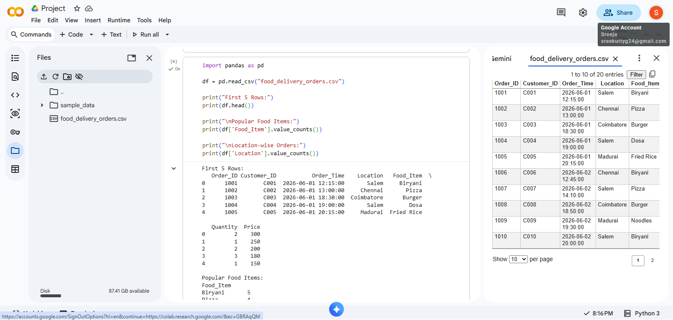

Display first five rows of dataset.
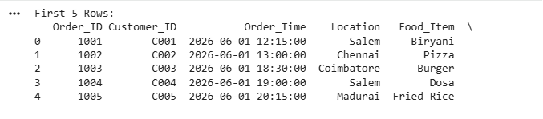

Peak Order Time Analysis
Bar chart showing order count by hour.
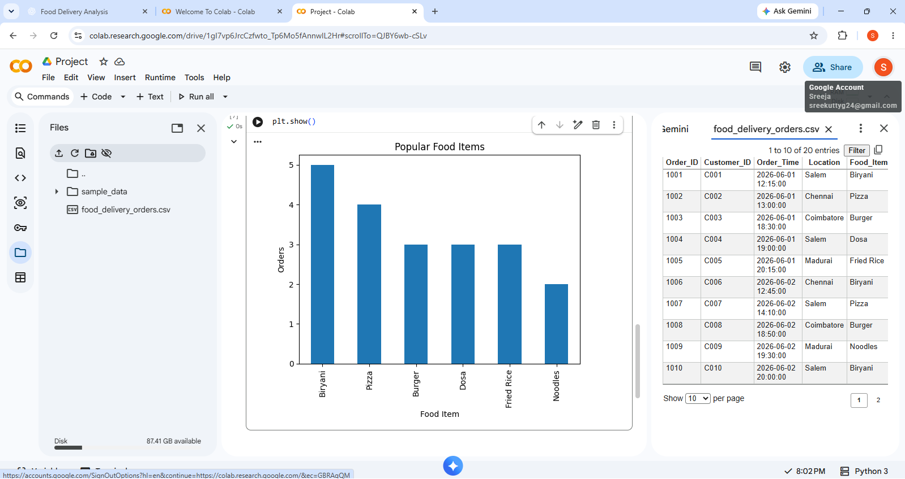

Popular Dishes Analysis
Top 10 most ordered food items.
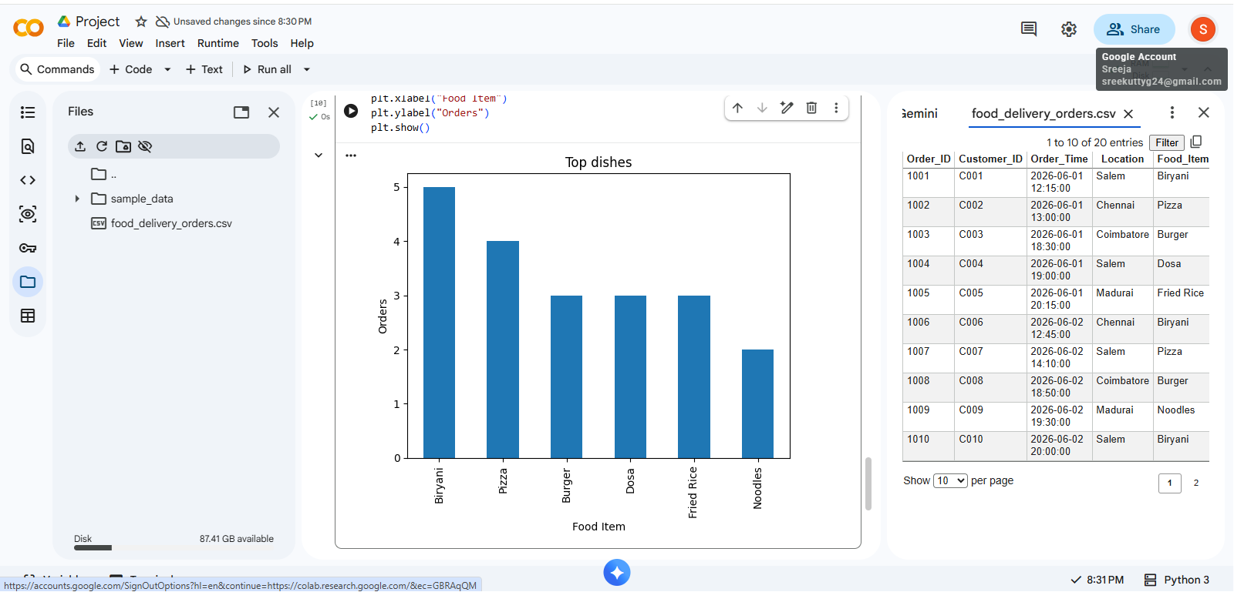

Location Analysis

Orders distribution across locations.
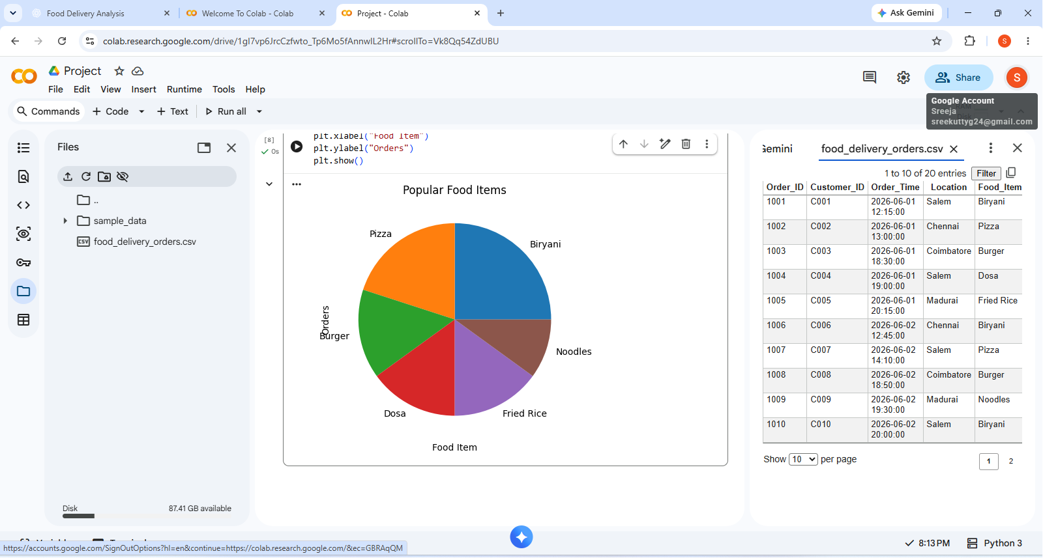

Dashboard
Combined visualizations showing:
- Peak order times
- Popular dishes
- Location-wise demand

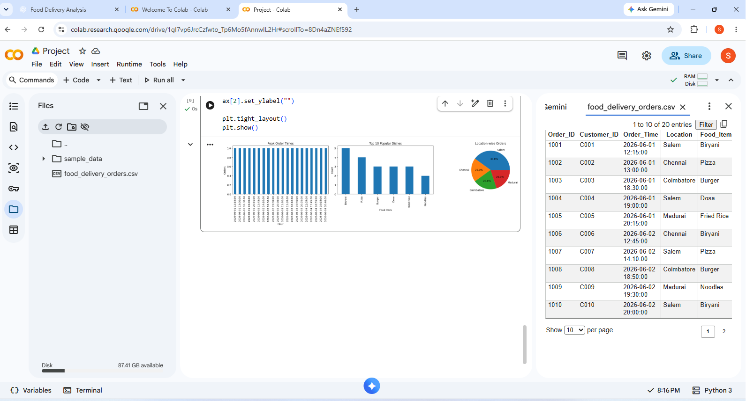

9. CHALLENGES FACED

Challenge 1
Missing values in dataset.
Solution:
Used Pandas functions such as dropna() and fillna().

Challenge 2
Incorrect date/time format.
Solution:
Converted using pd.to_datetime().

Challenge 3
Large amount of data.
Solution:
Used filtering and aggregation techniques.

10. LEARNING OUTCOMES

Technical Learning
- Data cleaning techniques.
- Data analysis using Pandas.
- Data visualization using Matplotlib.
- Dashboard creation.

Practical Experience
- Real-world business problem solving.
- Insight generation from datasets.
- Data-driven decision making.

11. CONCLUSION
The Food Delivery Sales & Customer Insights project successfully analyzed customer ordering patterns and food preferences. The analysis identified peak order times, most popular dishes, and location-wise demand trends. Visualizations helped transform raw data into meaningful business insights.
The project demonstrates how Python data analytics tools can support food delivery companies in improving operational efficiency, customer satisfaction, and business growth.

